**How to Build**

1. **Build OpenCV**
2. **Build Boost**

*Build the 32-bit libraries*

This installs the Boost header files under C:\Boost\include\boost-(version), and the 32-bit libraries under C:\Boost\lib\i386. Note that the default location for the libraries is C:\Boost\lib but you’ll want to put them under an i386 directory if you plan to build for multiple architectures.

1) Unzip Boost into a new directory.

2) Start a 32-bit MSVC command prompt and change to the directory where Boost was unzipped.

3) Run: bootstrap

4) Run: b2 toolset=msvc-12.0 --build-type=complete --libdir=C:\Boost\lib\i386 install

For Visual Studio 2012, use toolset=msvc-11.0

For Visual Studio 2010, use toolset=msvc-10.0

5) Add C:\Boost\include\boost-(version) to your include path.

6) Add C:\Boost\lib\i386 to your libs path.

*Build the 64-bit libraries*

This installs the Boost header files under C:\Boost\include\boost-(version), and the 64-bit libraries under C:\Boost\lib\x64. Note that the default location for the libraries is C:\Boost\lib but you’ll want to put them under an x64 directory if you plan to build for multiple architectures.

1) Unzip Boost into a new directory.

2) Start a 64-bit MSVC command prompt and change to the directory where Boost was unzipped.

3) Run: bootstrap

4) Run: b2 toolset=msvc-12.0 --build-type=complete --libdir=C:\Boost\lib\x64 architecture=x86 address-model=64 install

For Visual Studio 2012, use toolset=msvc-11.0

For Visual Studio 2010, use toolset=msvc-10.0

5) Add C:\Boost\include\boost-(version) to your include path.

6) Add C:\Boost\lib\x64 to your libs path.

1. Set VC++ Directories

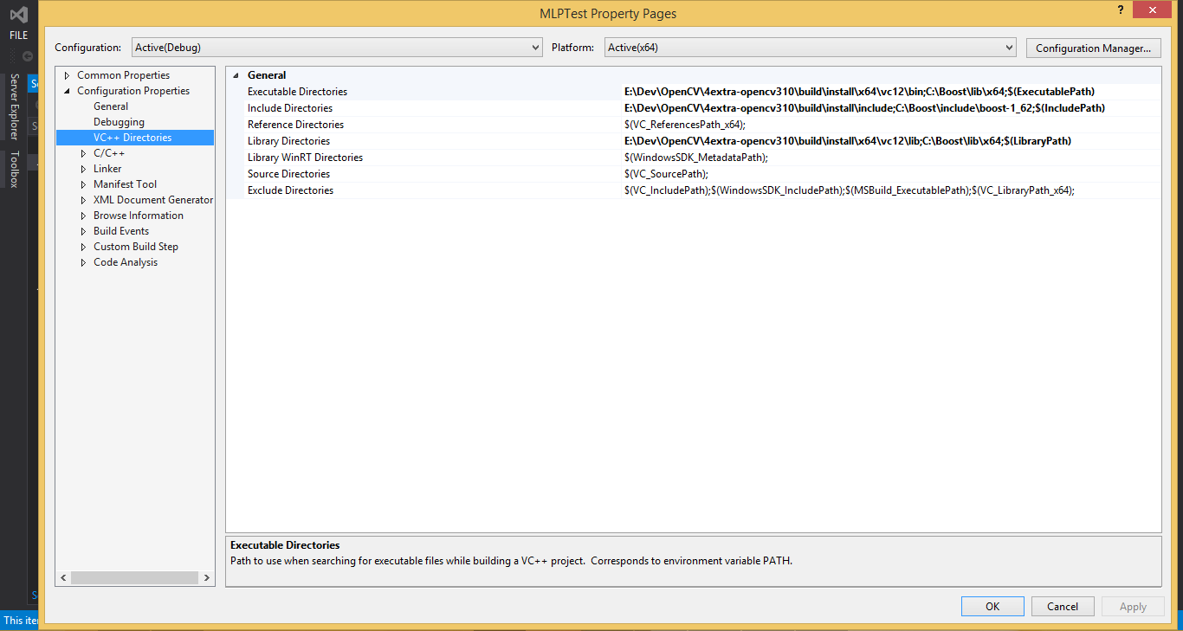

1. Link DLLs

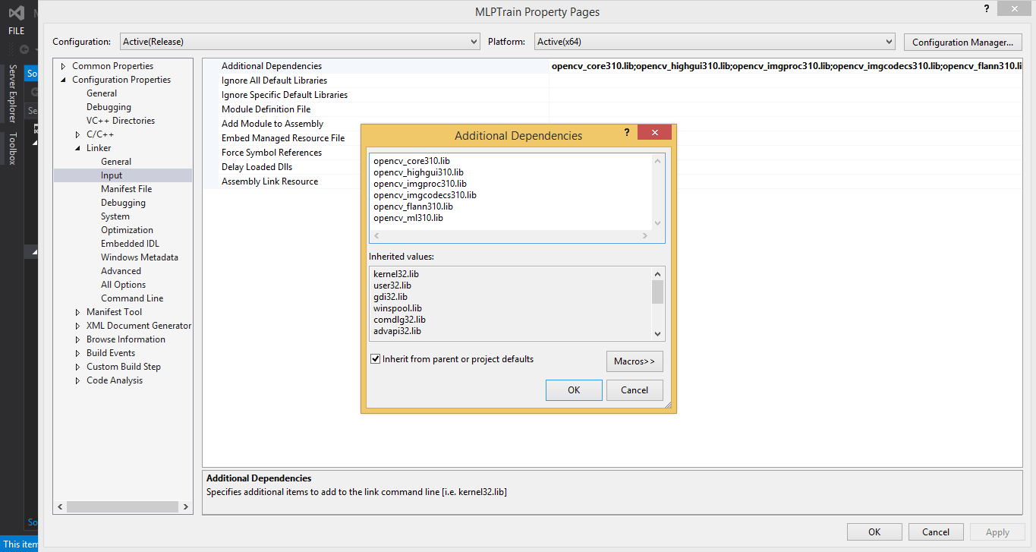

1. PrepareData

$(mlp_root_dir)/TrainingData/$(prjname)/$(classA)

$(mlp_root_dir)/TrainingData/$(prjname)/$(classB)

$(mlp_root_dir)/TrainingData/$(prjname)/$(classC)

……

$(mlp_root_dir)/TrainiedData/$(prjname)

$(mlp_root_dir)/TestData/$(prjname)

$(mlp_root_dir)/OutData/$(prjname)/$(classA)

$(mlp_root_dir)/OutData/$(prjname)/$(classB)

……

I used boost1.62.0, opencv3.1.0 and VS2013 for this project.

Attention:

You can encounter odd errors when you connect x86 dlls to x64 project. Please be aware of it.

**How to Use**

1. Open CMD
2. Train

MLPTrain.exe nameofclassA nameofclassB

1. Test

MLPTest.exe nameofclassA nameofclassB testcount